Meetings of Alumni Association Executive members and Alumnae 2014 to 2019
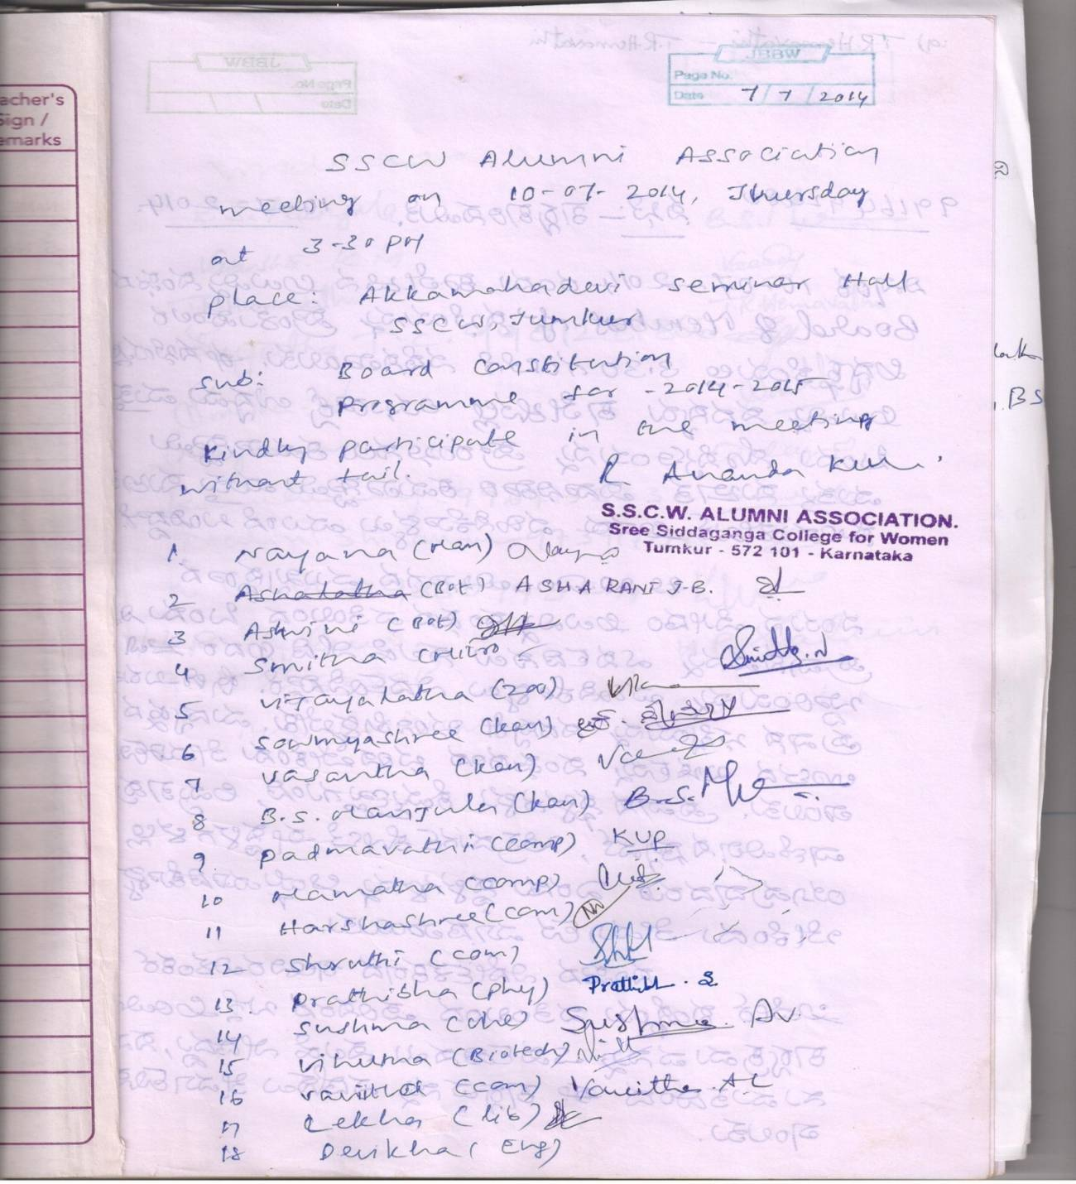
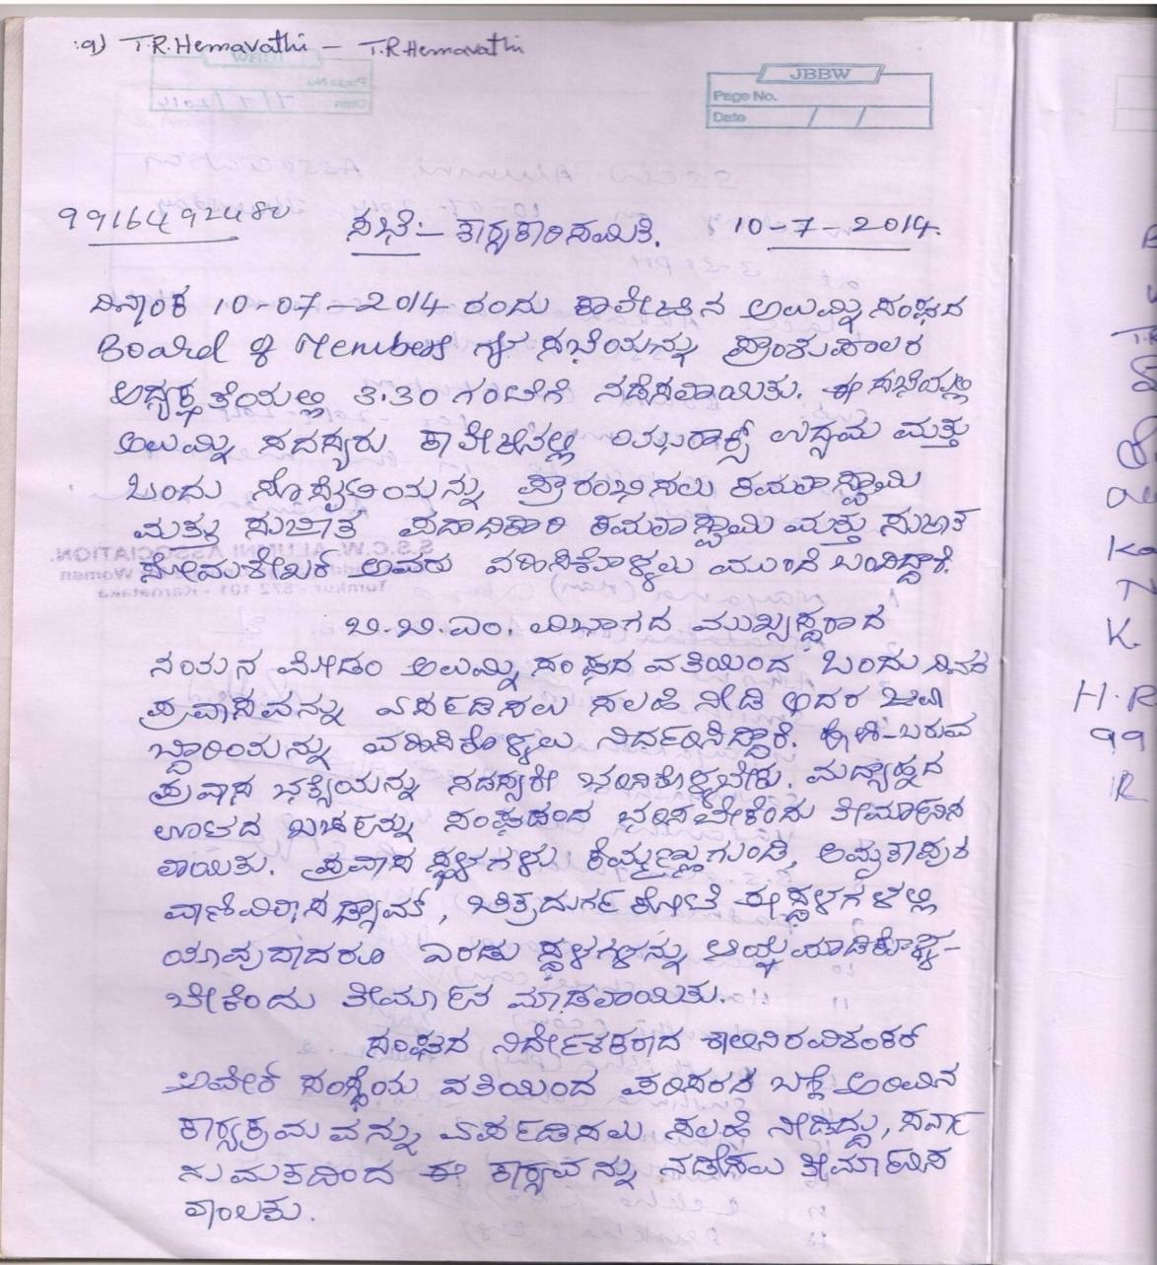
Executive Committee Meeting 10-07-2014

On 10-07-2014, the alumni executive committee was held in the principal’s chamber at 3.30 pm. A day trip was planned from the alumni association and the responsibility of the trip was given to Nayana.M, Head of the department of BBM. Alumni director Smt. Shalini Ravishankar suggested arranging an Environmental awareness programme in association with AWARE organization.
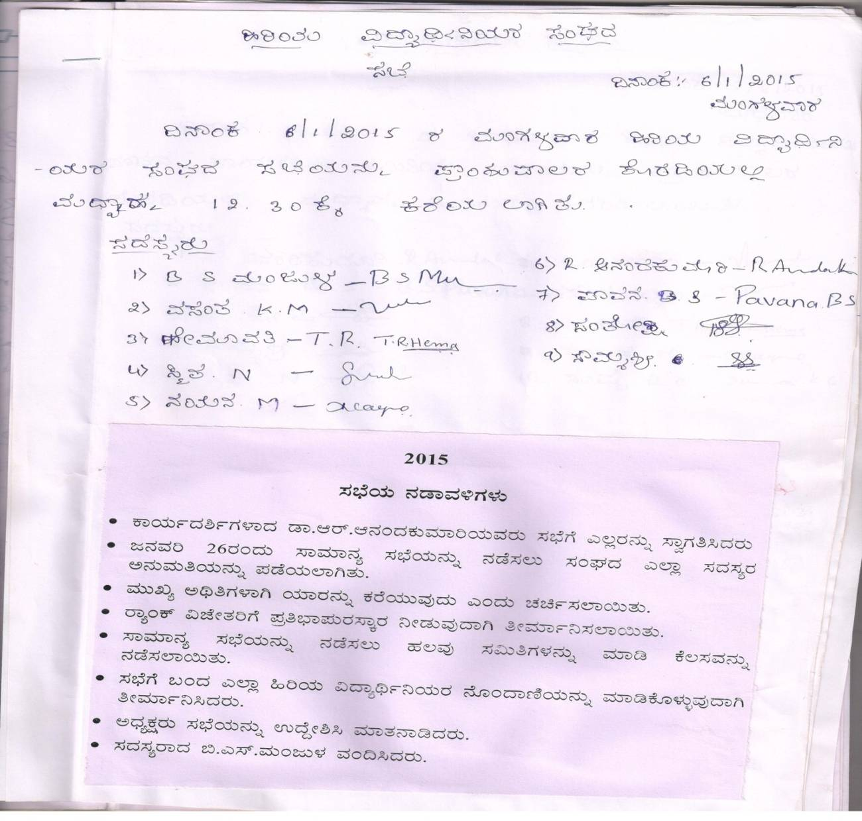

Alumni members meeting 06-01-2015

Alumni members meeting was held in the principal’s chamber on 6-1-15 at 12.30 pm. The directors decided to conduct annual general meeting on 26-1-2015. It was also decided to honor the rank holders of the year 2014-15.

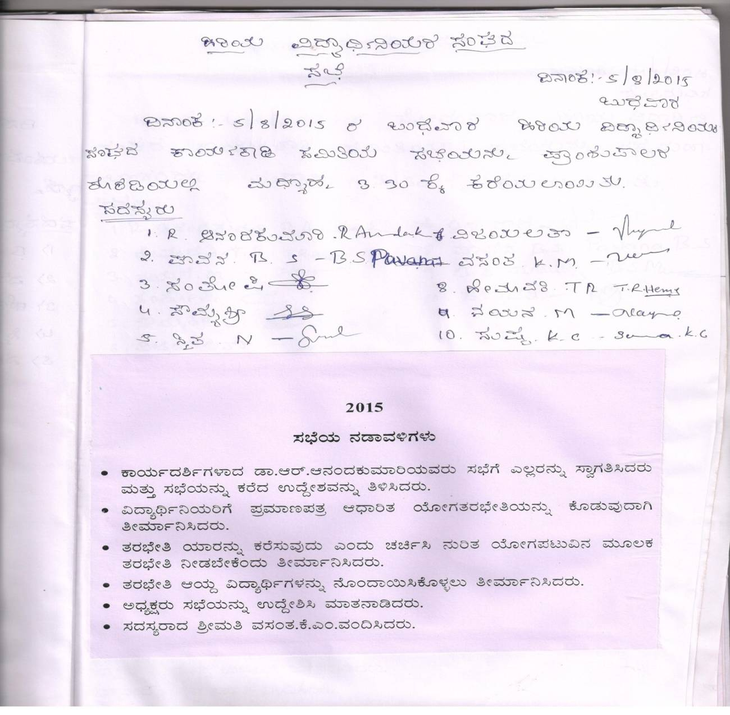
Alumni members meeting 5-8-2015

The alumni association of Sree Siddaganga College for women met on 5-8-2015 at 3.30 pm. The committee decided to organize certificate based yoga training programme to all the students, staff and alumni members in the semester.
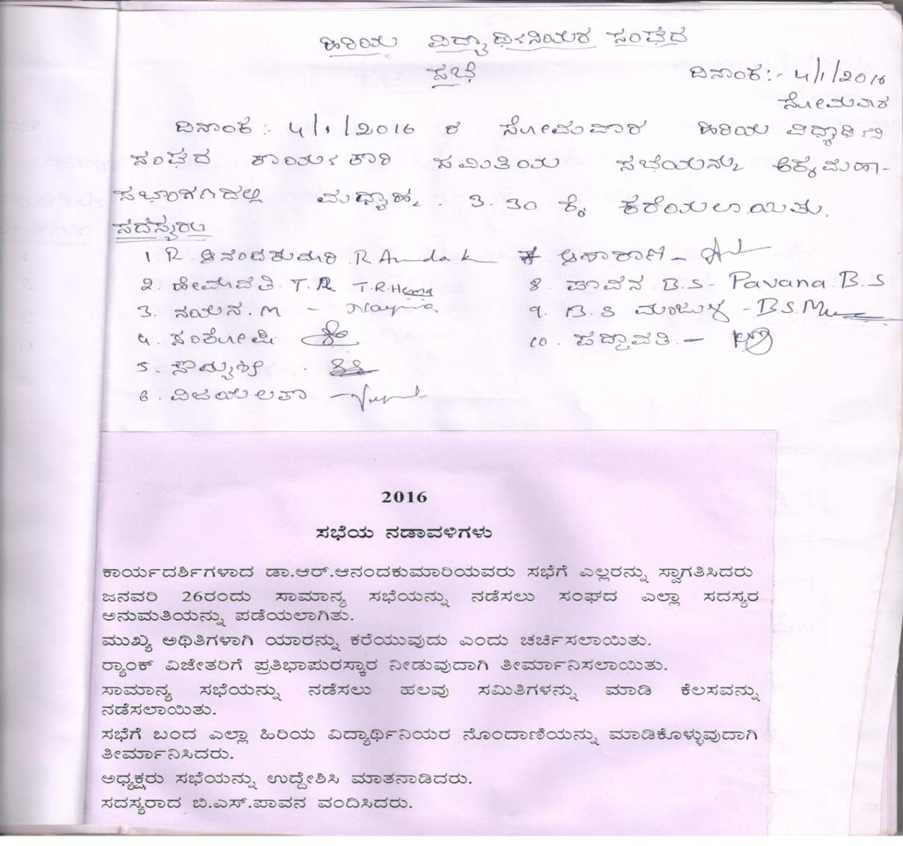
Alumni members meeting 4-1-2016

The alumni association meeting was held on 4-1-2016 in the principal’s chamber at 3.30 pm. The association came out with the preparation of the annual general meeting to be held on 26-1-16. Felicitation for the rank holders was also the main programme in AGM.

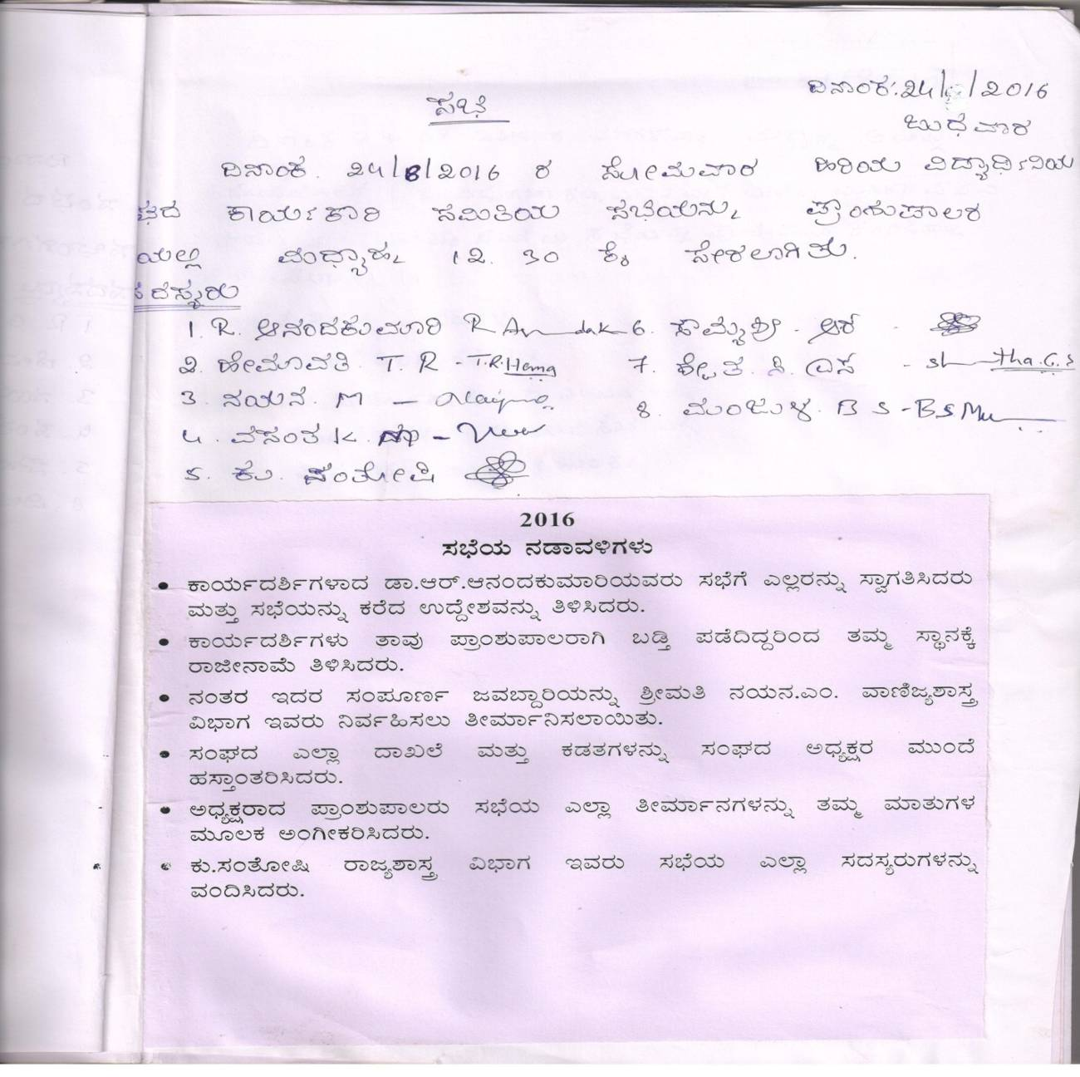

Alumni members meeting 24-8-2016

The alumni association members met on 24-8-16 at 12.30 pm on 24-8-16. Transfer of the secretary ship from Dr. R.Ananda Kumari to Nayana.M due to administrative reasons.
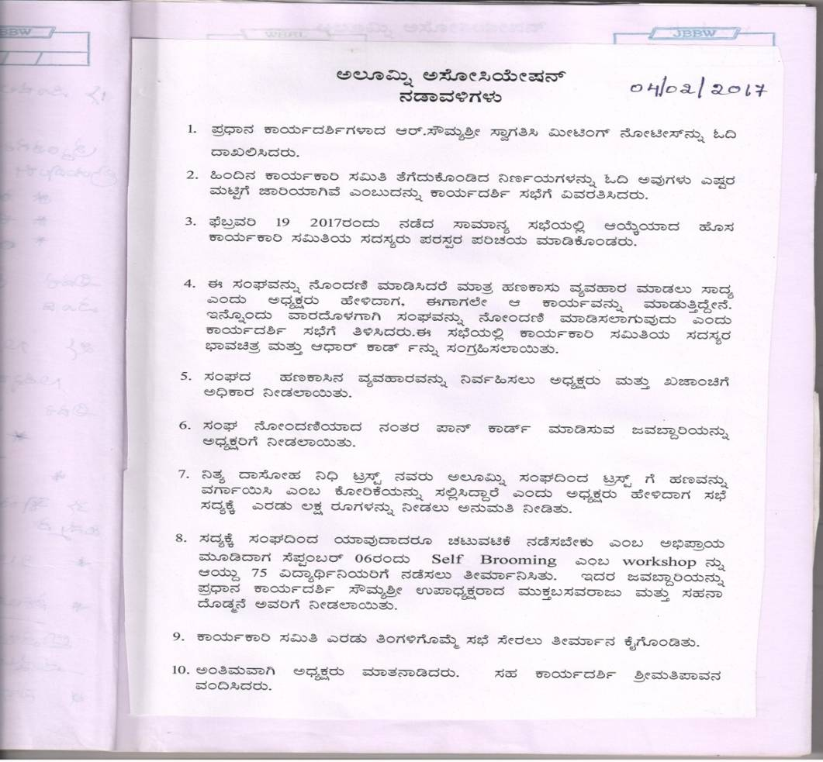
Executive Committee Meeting 4-2-2017

The alumni association meeting was held on 4-2-2017 at 3.30 pm. New members, directors of the association interacted and introduced themselves to the committee. The association registration was the main agenda of the meeting. President, treasurer were given the authorized signatory powers. 2 lakh rupees from alumni association was transferred to the Nithya dasoha trust on their request.
New members and directors decided to organize a day workshop on “Self Grooming” on personality development for the students.

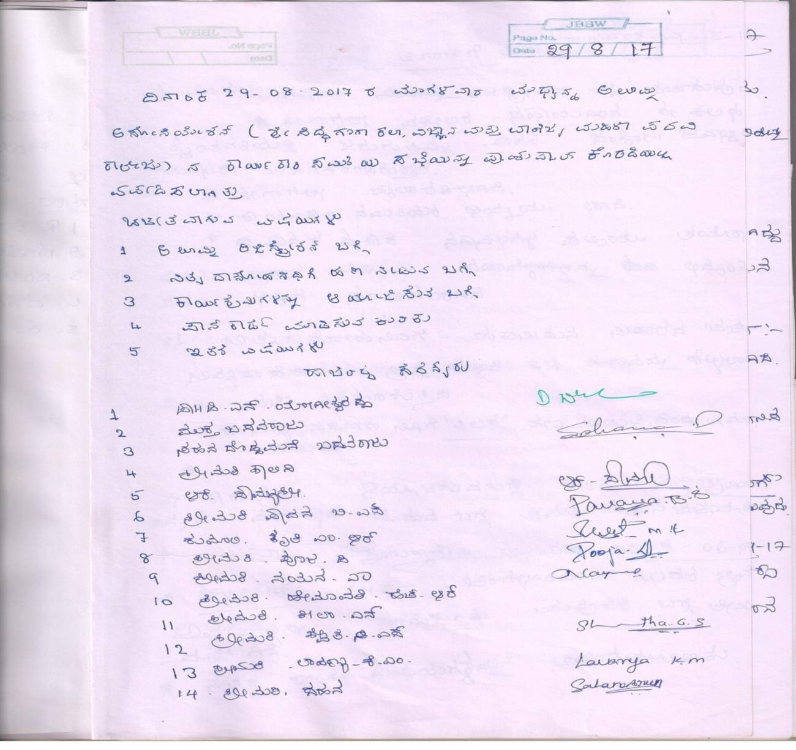
Executive Committee Meeting 29-8-2017
A meeting was held on 29-8-2017 by the executive committee in the principal’s chamber with an agenda of registration of alumni association, fund transfer from alumni association to nitya dasoha trust and organizing the student oriented programme in the campus and pan card registration for the alumni association. The byelaw was prepared and it was entirely prepared by principal of the college.

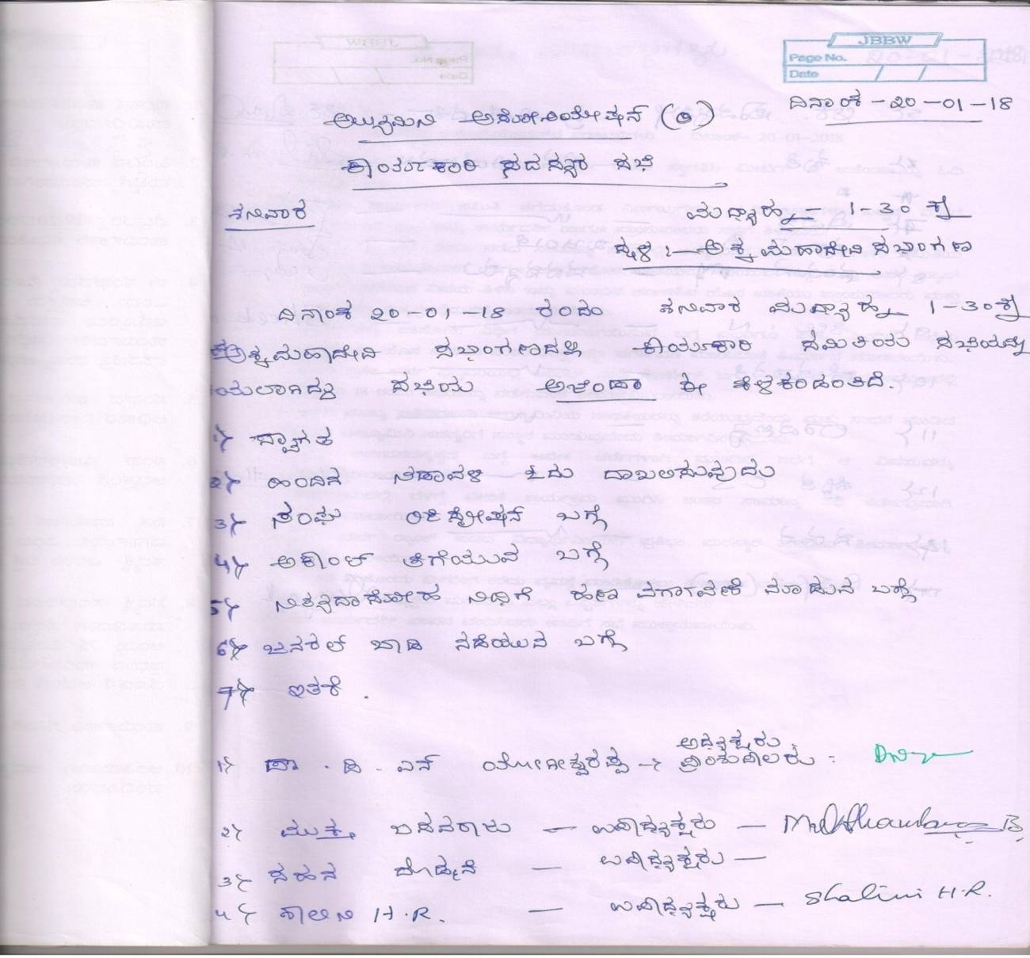
Alumni members meeting 20-1-2018

The meeting was held on 20-1-2018 at 1.30 pm at Akkamahadevi Sabhangana under the president ship of the principal. Registration of Alumni association was announced and the separate bank account for the alumni association was discussed. February 18-2-18 was fixed as the date for annual general body meeting. The committee decided to felicitate the alumni achievers of the college on the AGM. Lifetime membership was declared as the agenda of the next meeting.
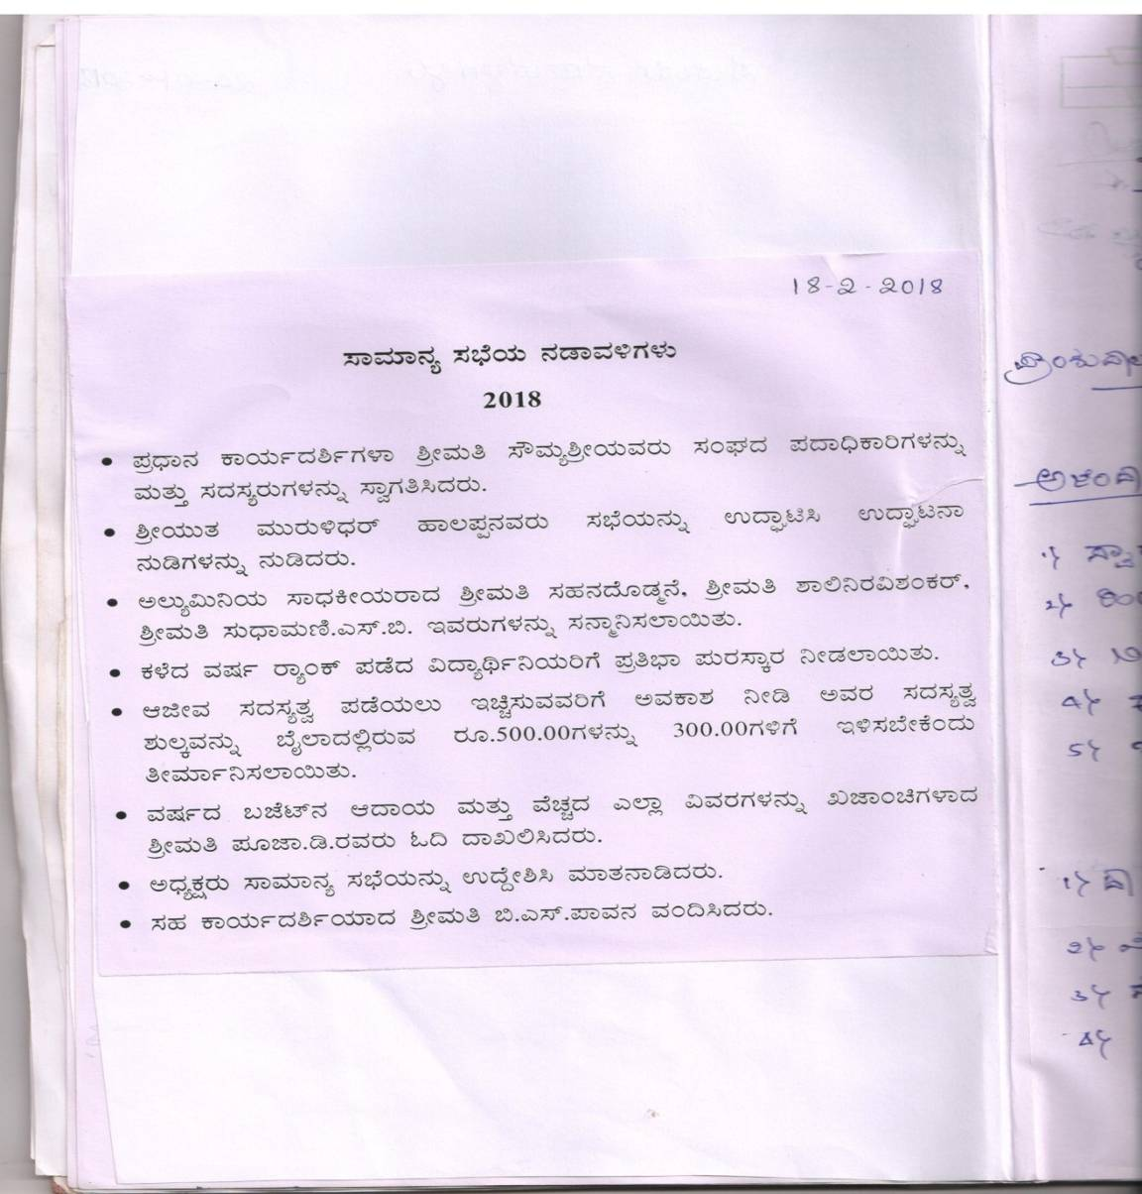
Annual General Body Meeting 18-2-2018

In annual general body meeting Sahana Dodmane, Shalini Ravishankar and Sudhamani were felicitated. The membership fee of Rs.500 was decreased to Rs.300. The treasurer from the association Pooja.D of Commerce department read the budget for the year 2017-18.

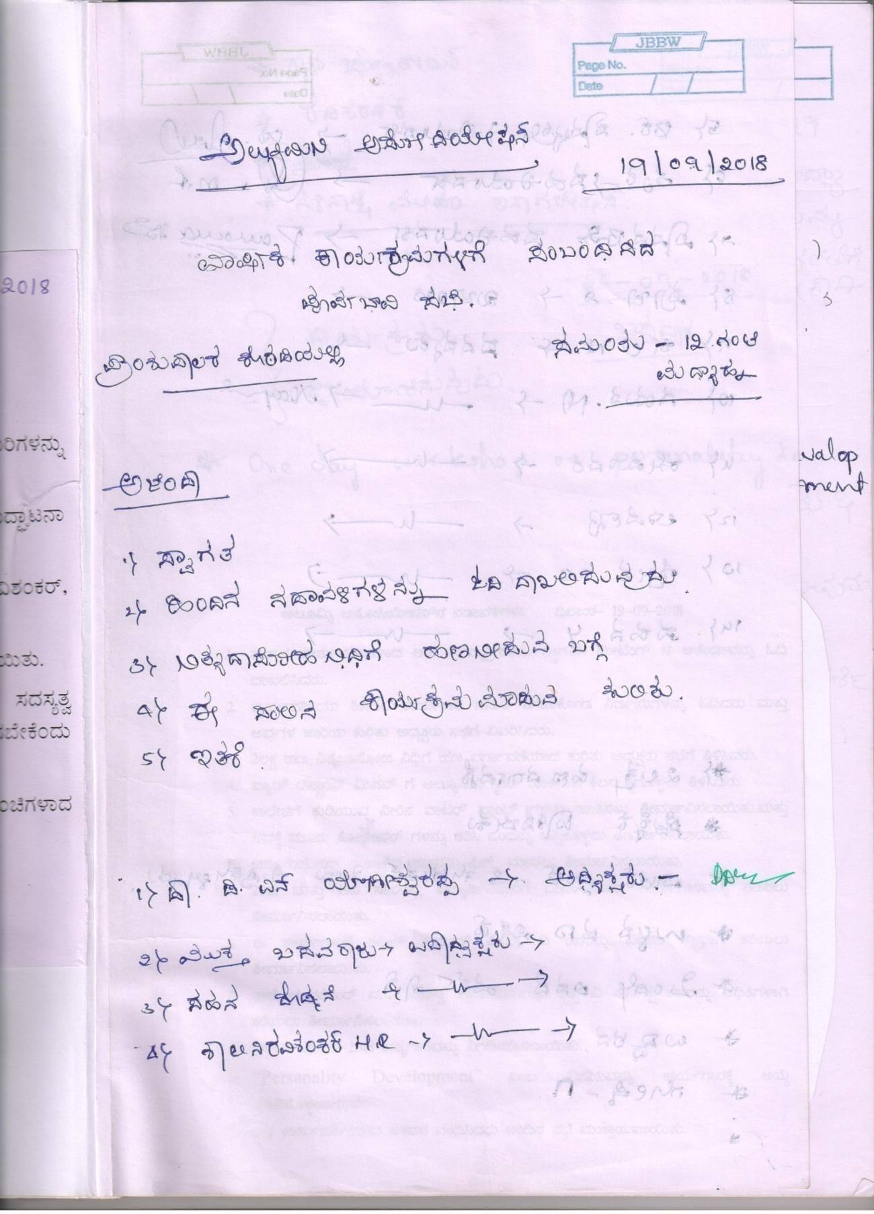
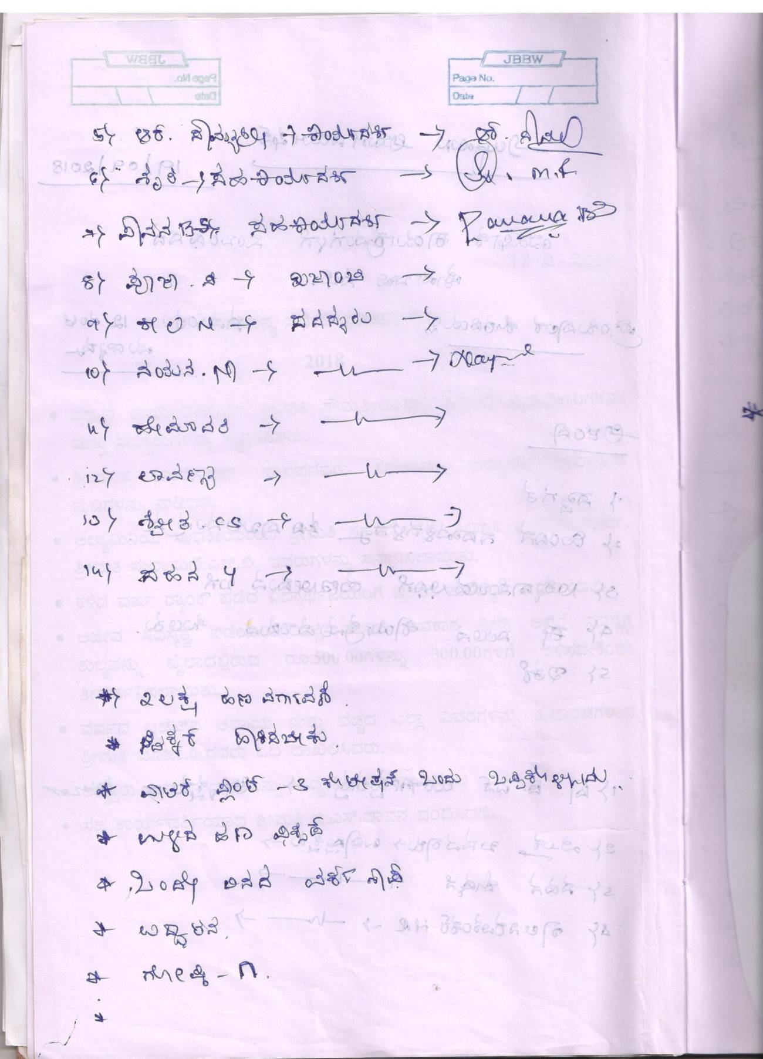
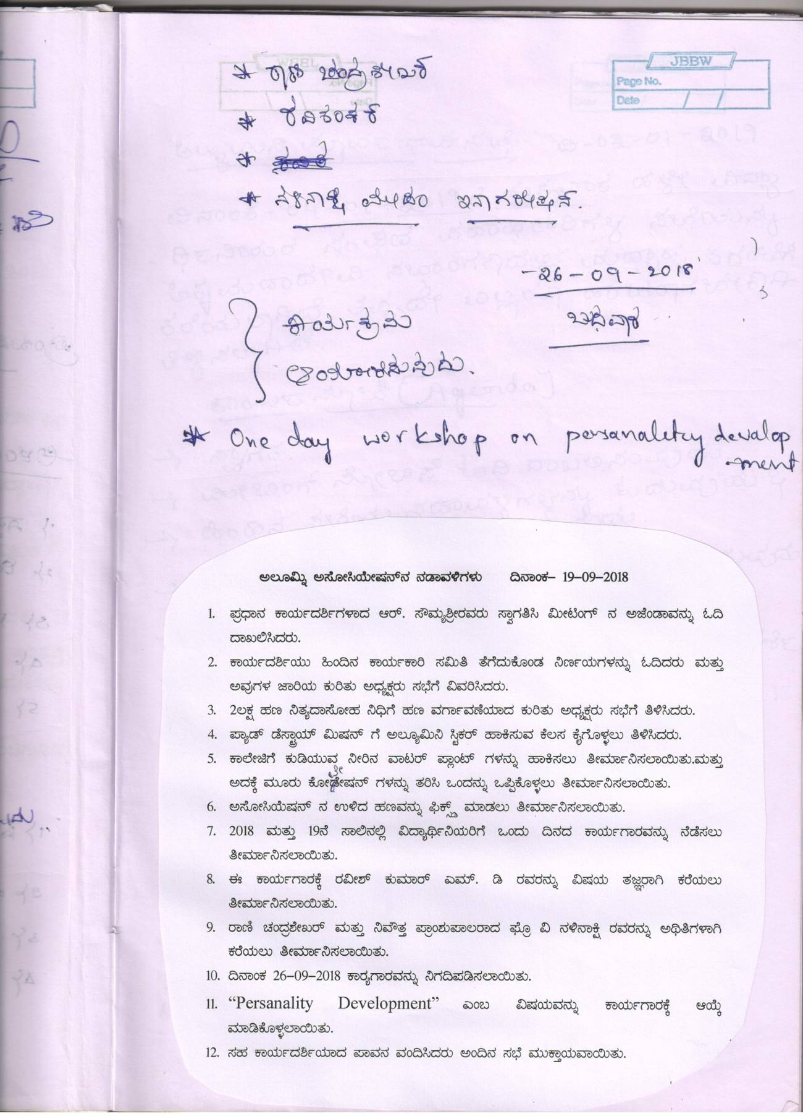
Alumni members meeting 19.9.2018

Alumni meeting held at 12 noon on 19.9.2018 in the principal’s chamber. Programme to be conducted was discussed. A day workshop on personality development by Mr.Raveesh Kumar on 26.9.18 was to be organized. The committee decided to invite Prof.V.Nalinakshi to inaugurate the programme.
The alumni association had donated 2 incinerators and 1 sanitary pads vending machine to the college.
In this year the association decided to invite quotations for pure drinking water filters in the college campus. Thus 2 pure drinking water filters were installed in the campus.
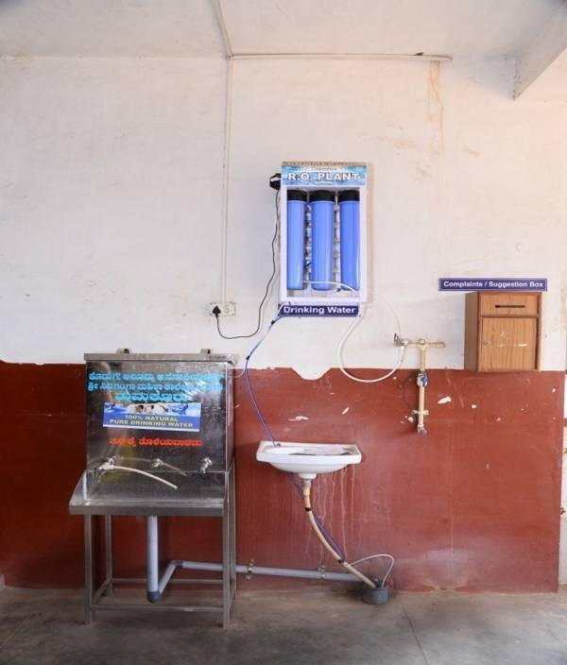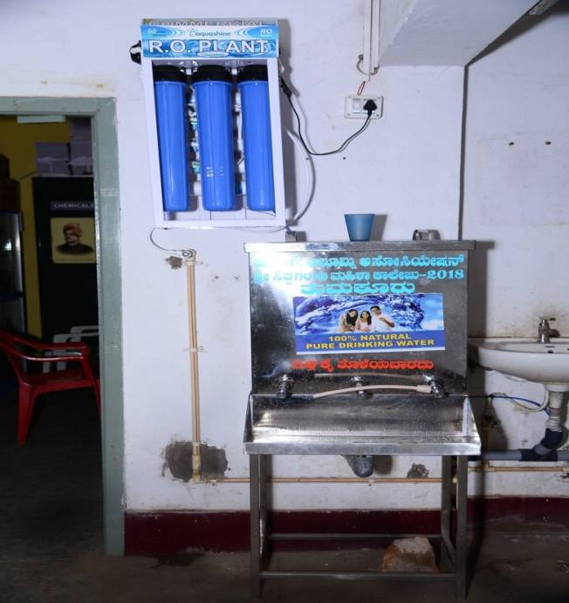

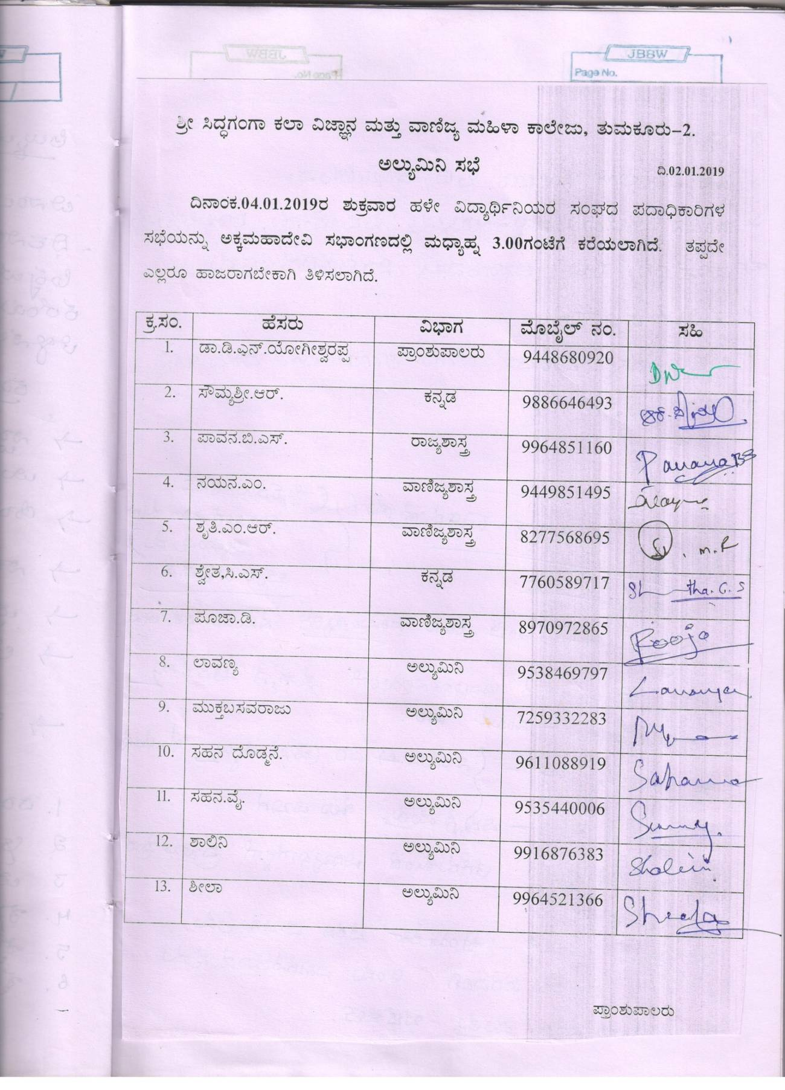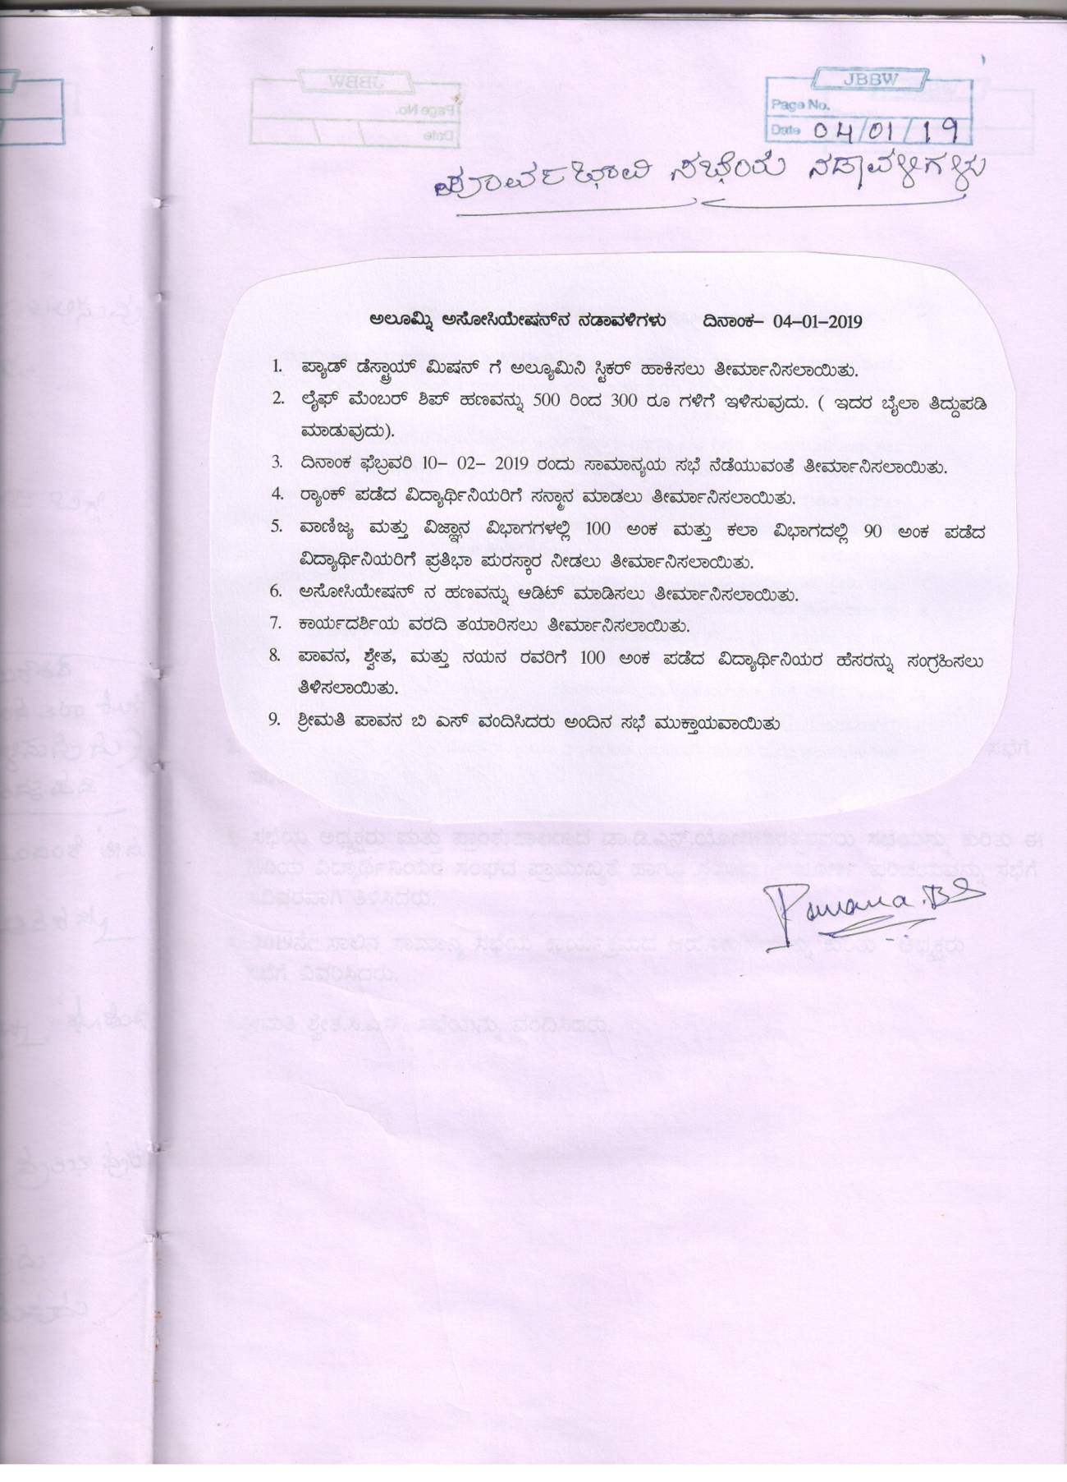
Executive Committee Meeting 4-1-2019

The executive committee meeting was held in the Akkamahadevi Seminar hall at 3 pm on 4-1-2019. Annual general meeting date was decided. Felicitation to the rank holders, accounts of the year and secretary report was finalized, pasting stickers to the incinerators and vending machines was finalized. The life membership amount reduction should be edited in the byelaw of the association.
February 10-2-19 was decided for the AGM. Rank holders felicitation, honoring the gold medalist PG alumni, meritorious students of the current year (100/100 in commerce & science students and 90 above in arts stream).
Yearly auditing of the alumni association fund was finalized. Secretary report was assigned to be prepared. Pavana.B.S, Nayana.M, Shwetha.C.S faculties from the college was assigned to identify meritorious students.

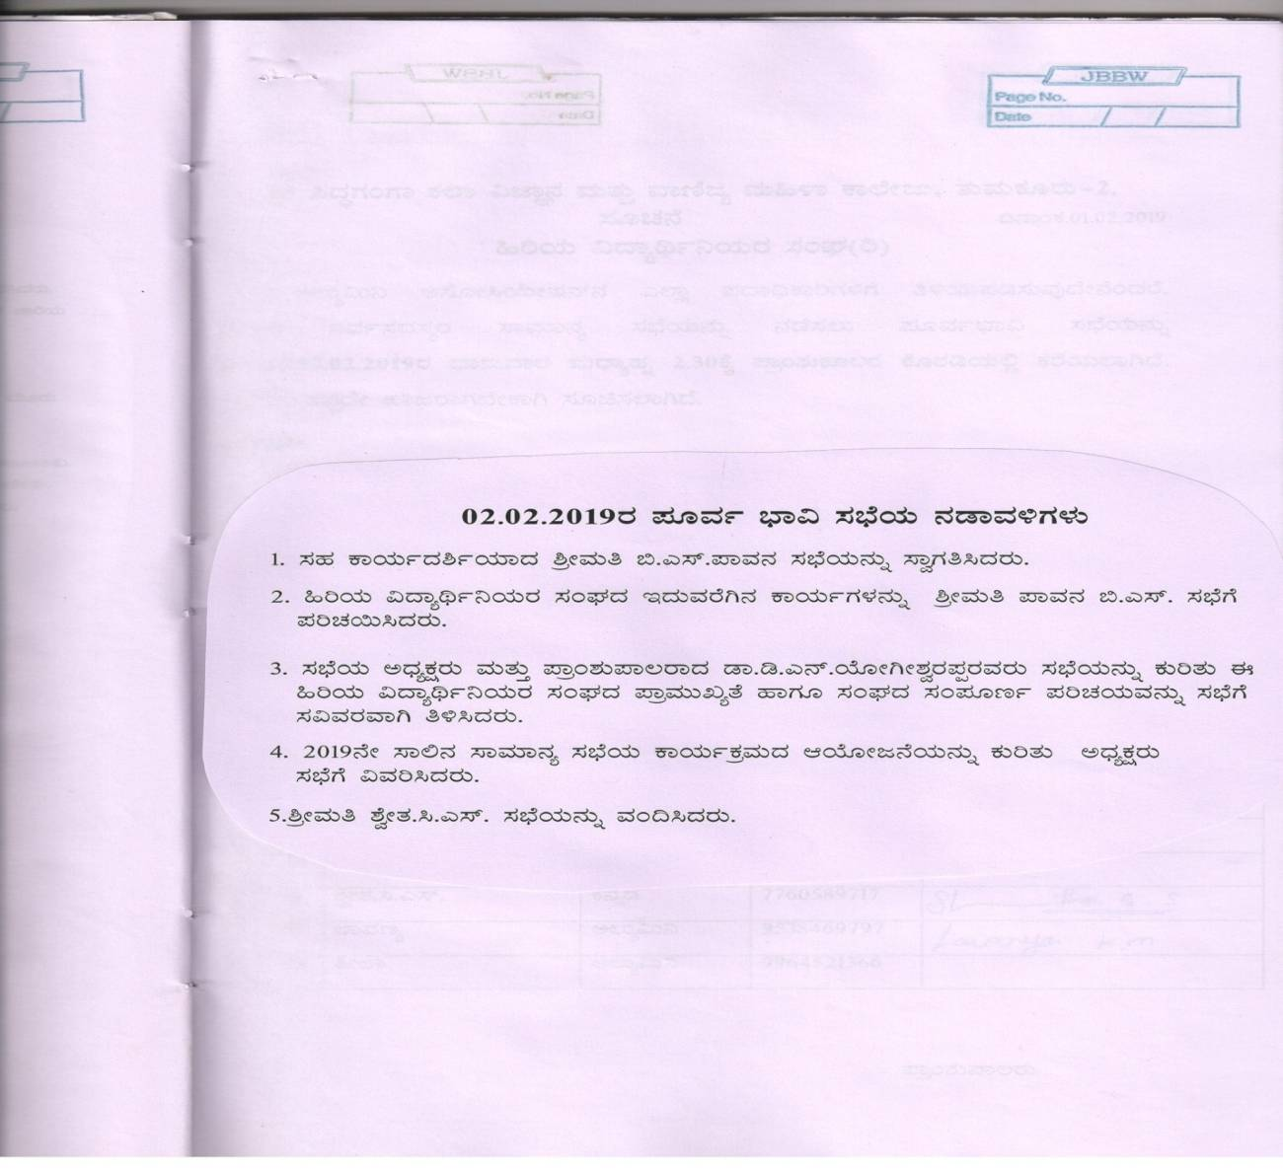
Alumni members meeting 2.2.2019
A meeting was organized in the Akkamahadevi seminar hall for all the ladies staff of the college with regard to the arrangement of the annual general body meeting of alumni association 2019.

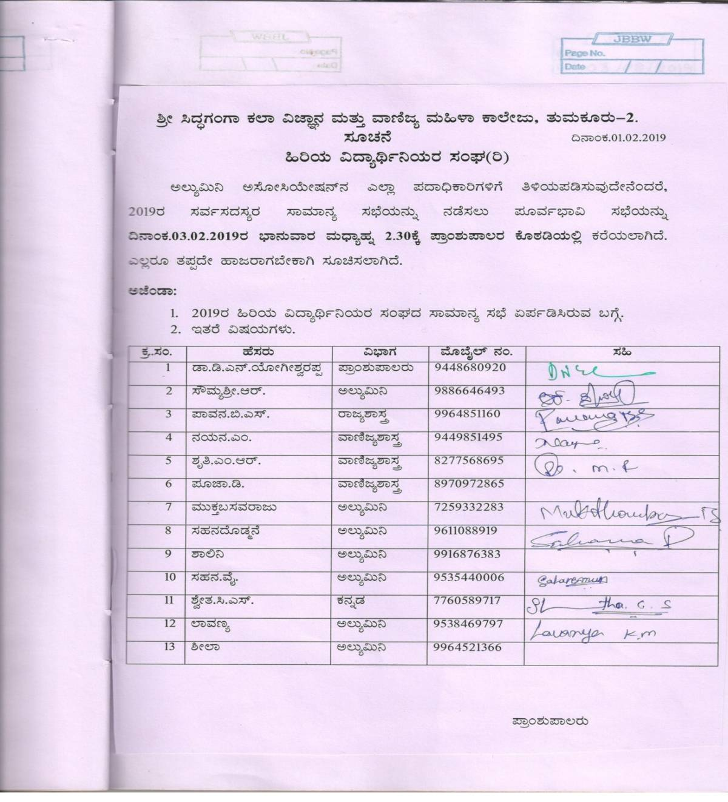
Executive committee meeting 3-2-2019

Executive committee meeting was held on 3-2-2019, Sunday at 2.30 pm in principal’s chamber. Corrections in the secretary report was discussed, audit report was introduced to the committee. The programme plan for the annual general meeting to be held on 10.2.2019 was assigned to the members of the committee.

