NETSIM
Inaugural & Certificate Distribution Ceremony

NETSIM inaugural function for I year BCA and I PMCs students and Certificate distribution program for II year PMCs students was organized by department of computer science on 7th August 2019 in Seminar Hall of our college.
There was a colorful welcome followed by lighting of the lamp. It was accompanied by a melodious invocation of Lord Ganesha. It was followed by a welcome speech given by the Mrs.Padmavathi K.V.
Program was inaugurated by our chief guest Dr. B.L Mukundappa, Associate Professor, Department of Computer Science, Tumkur University. The Chief Guest praised the entire event a lot. He guided with his inspirational words and inspired to do better. It was followed by certificate distribution to the students.
Talent awards was given to computer science subject toppers, this was award by our guest Dr. Ashagowda Karegowda Associate Professor, Department of MCA, SIT, Tumkur.
Program is presided by our beloved Principal Dr. Jayaswamy. He honored the guests. The whole details about NETSIM course and its beneficial information was given by Department HOD Prof Mahesha S. Vote of thanks speech was given by Mr. Irfan Ahmed.
Our faculty members Miss. Indushree M, Miss Sowmya R.B were presented in the program. The whole program was anchored by Major Arockia Swamy.

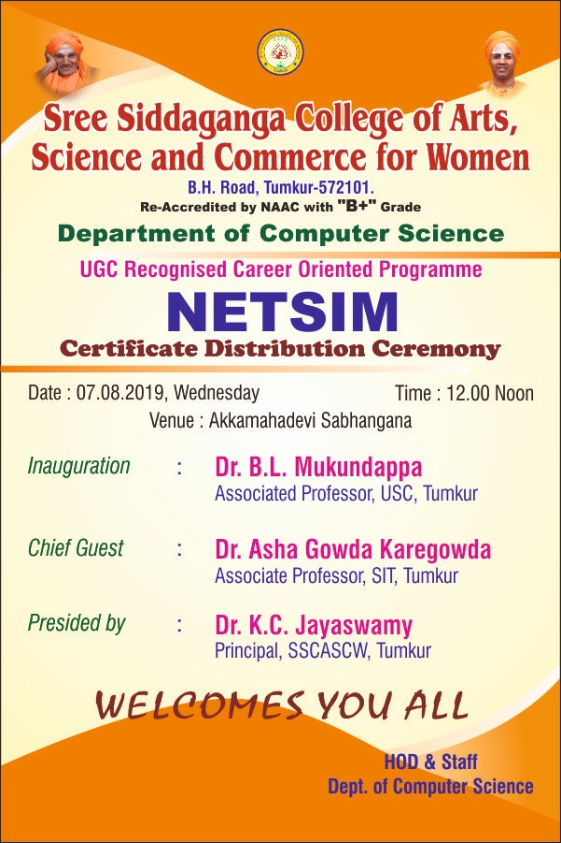

Sree siddaganga college of Arts, Science and Commerce for Women
Department of computer science
UGC Recognized career Oriented Programme
NETSIM
Inaugural & Certificate Distribution Ceremony
Date & Time: 07-08-2019 & 12:30

- Invocation : Miss. Anjali I BCA
- Welcome : Smt. Padmavathi K.V
- Lighting up of Lamp : Dr. B L Mukundappa
- Introductory Speech : Sri. Mahesha S
- Guest Introduction : Miss. Indushree M
- Inaugural Speech : Dr. B L Mukundappa
- Chief Guest Speech : Dr. Asha Gowda Karegowda
- Excellence Award : Dr. Asha Gowda Karegowda
- NETSIM certificate
Distribution : Dr. K C Jayaswamy
- Student’s Opinion : III Year Students.
II Year Students.
- Presidential Inference : DR. K C Jayaswamy
- Vote of thanks : Sri. Irfan Ahmed
- Anchoring : Major. P.Arockia Swamy

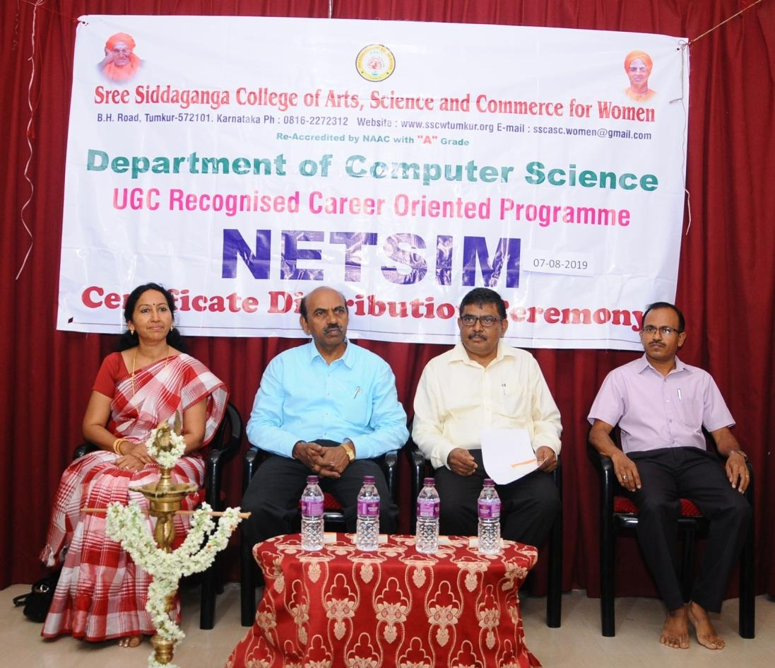

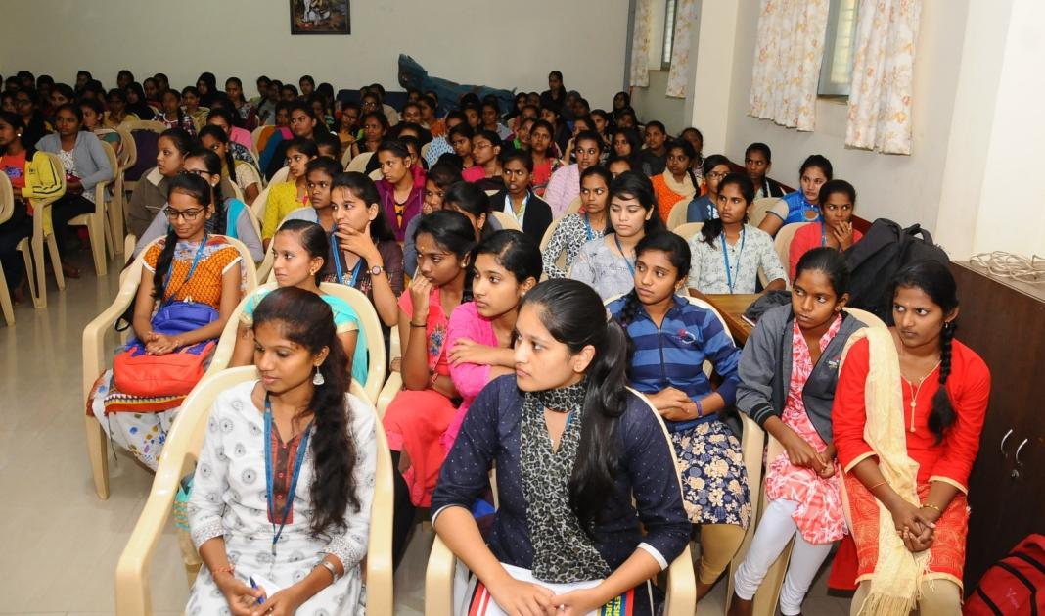

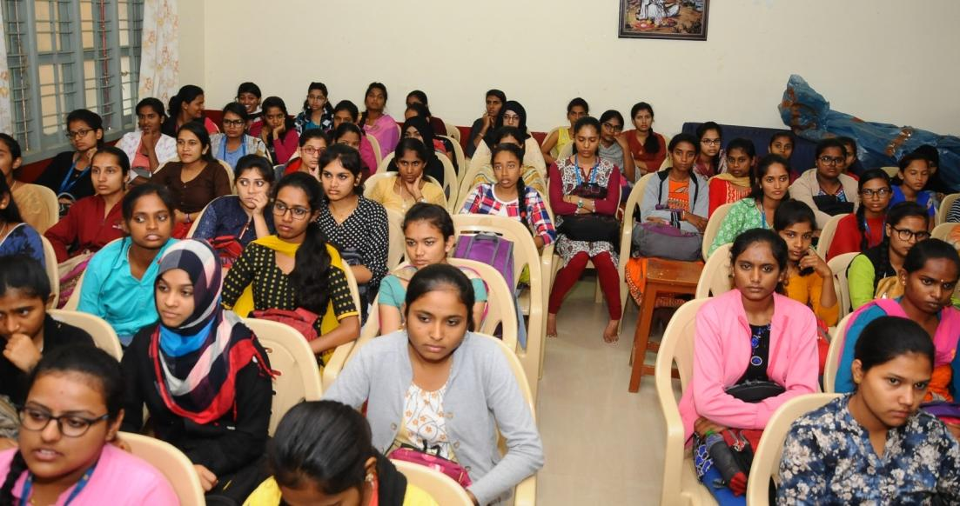
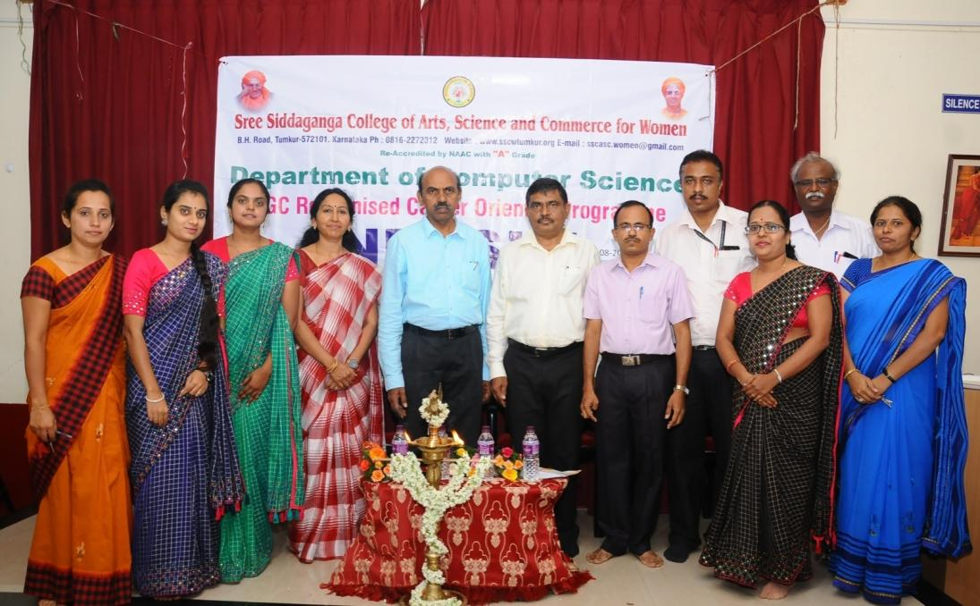
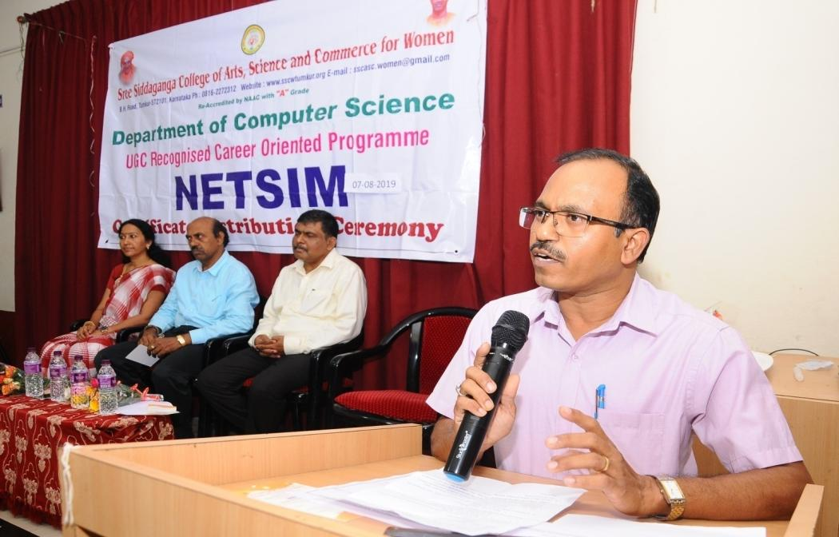
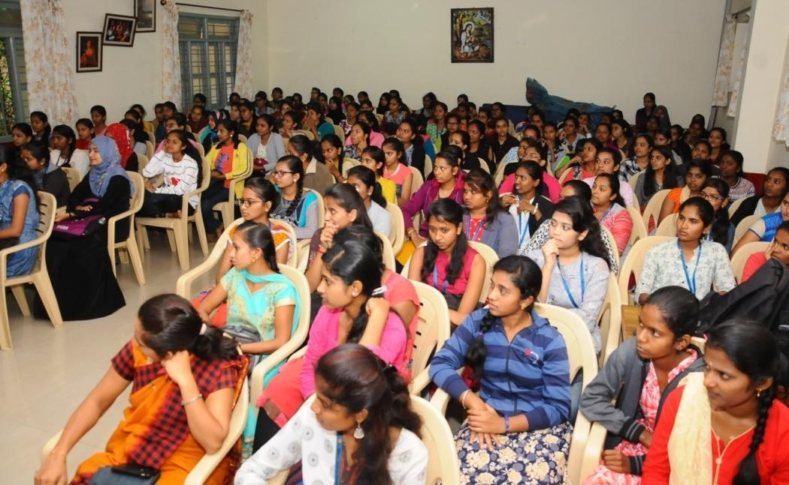
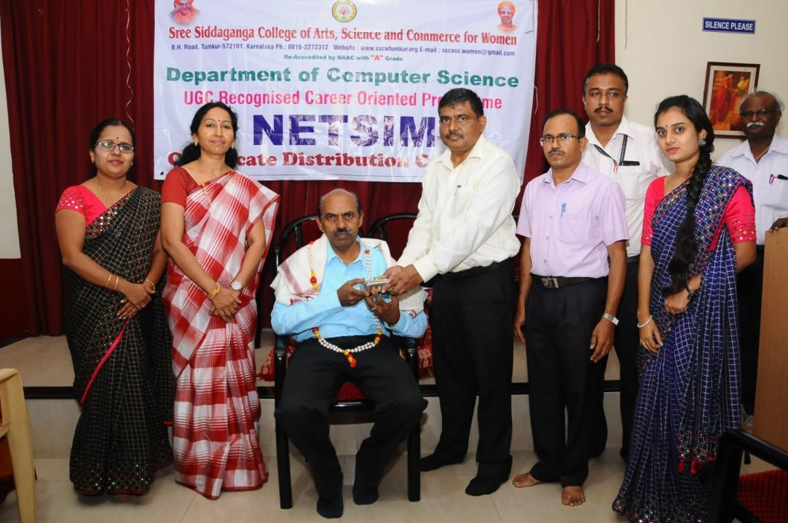
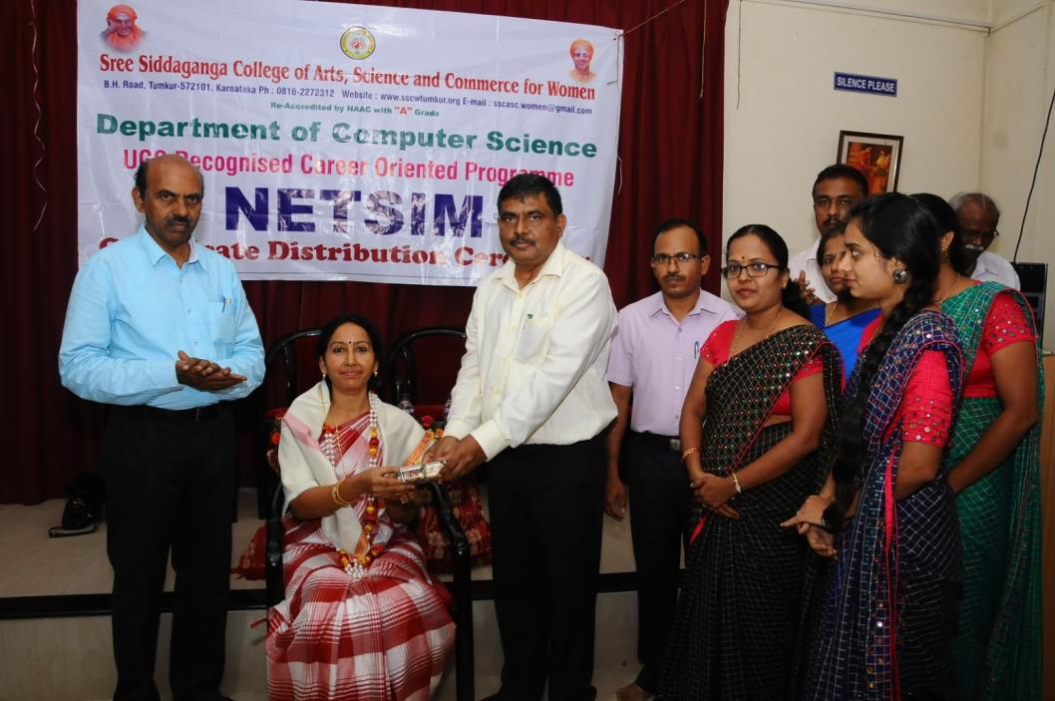
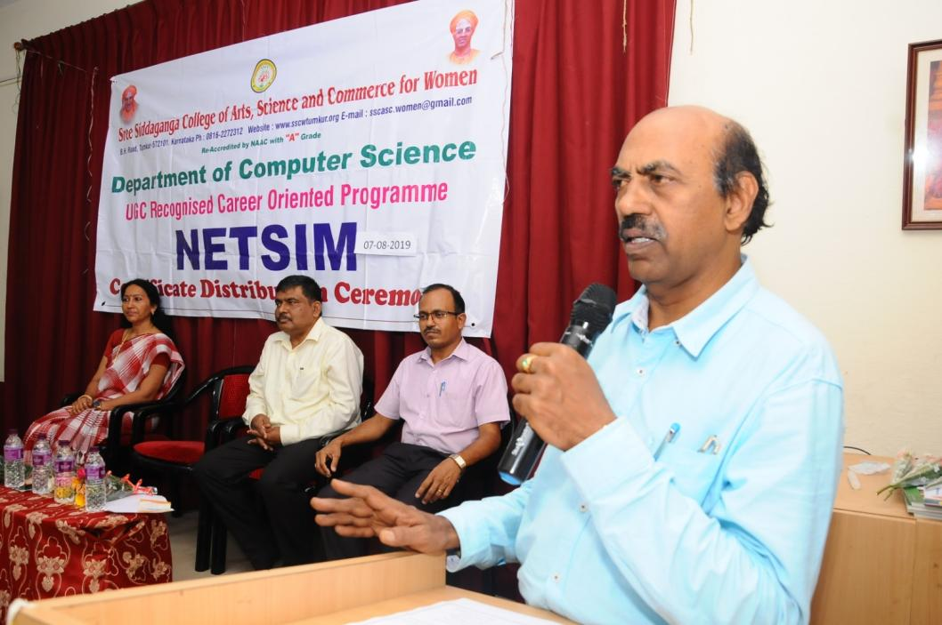
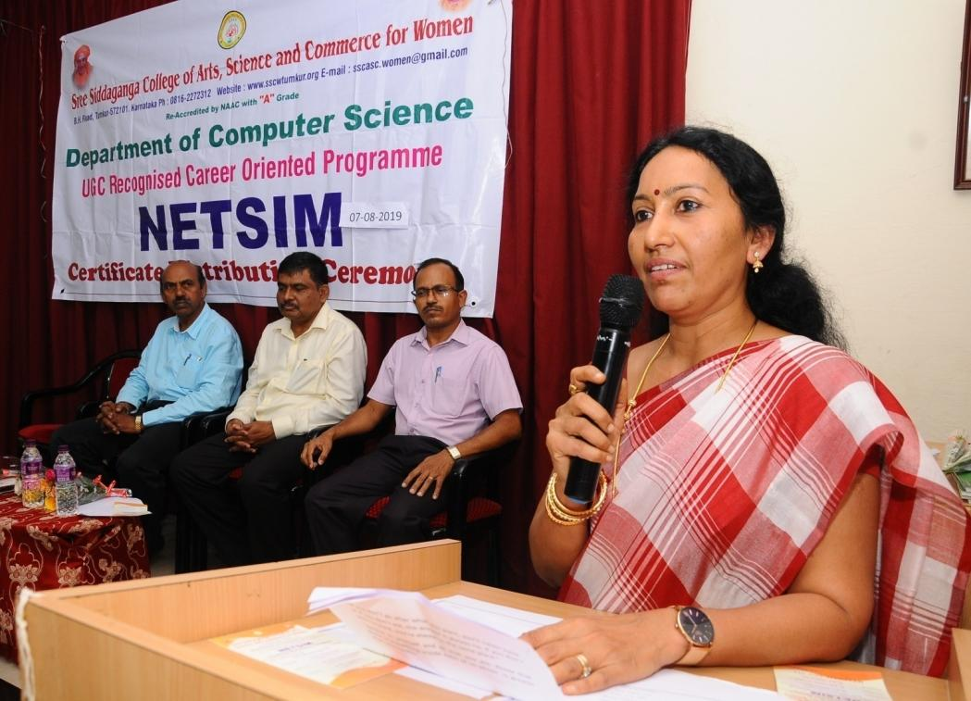
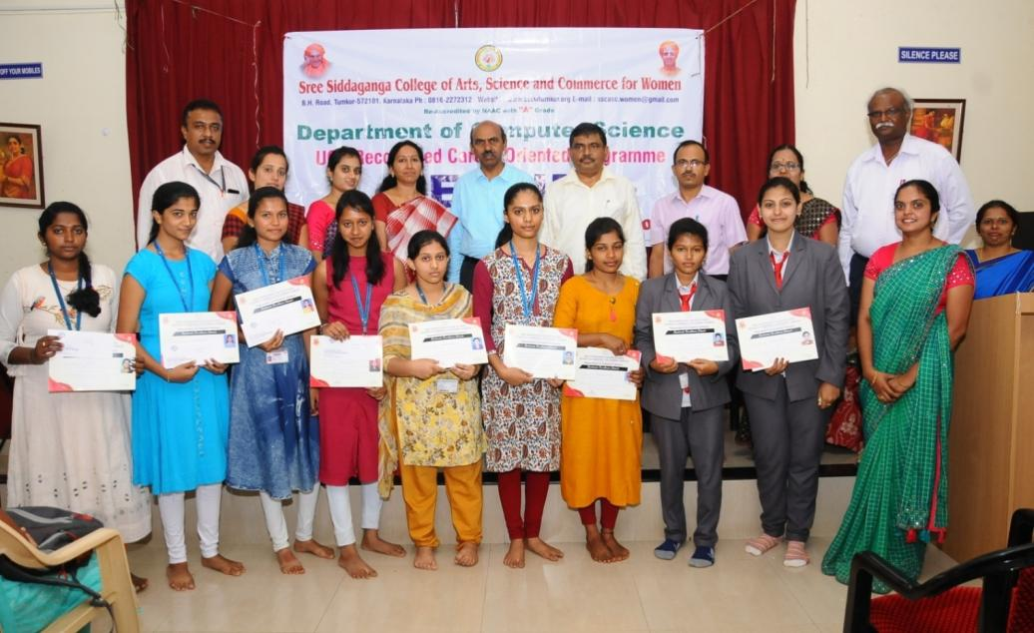
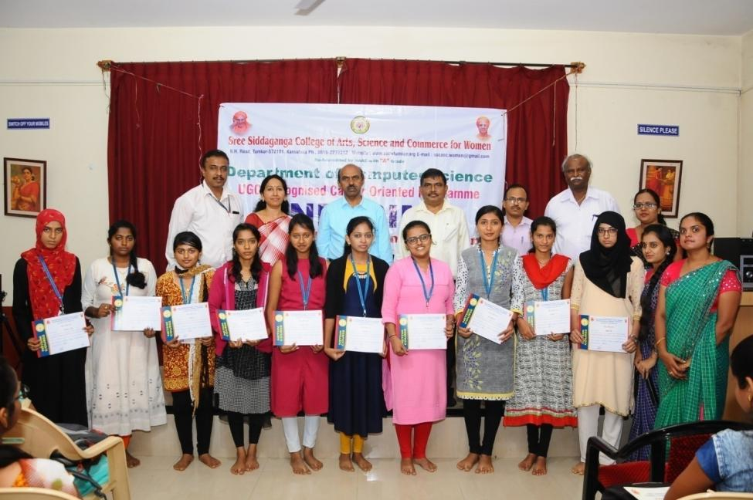
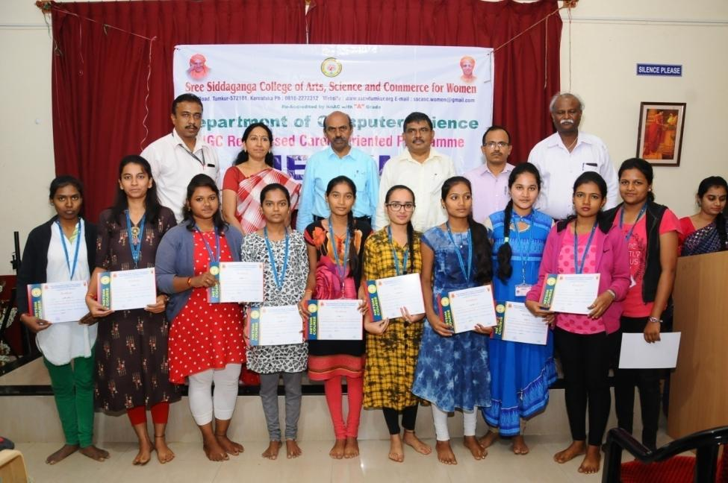
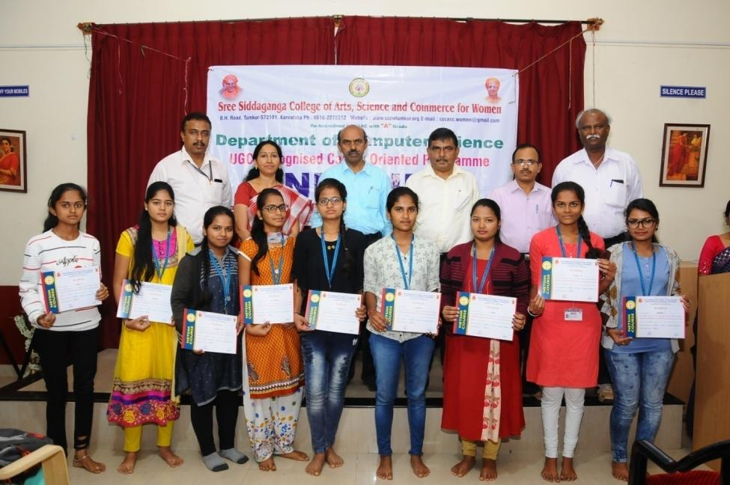
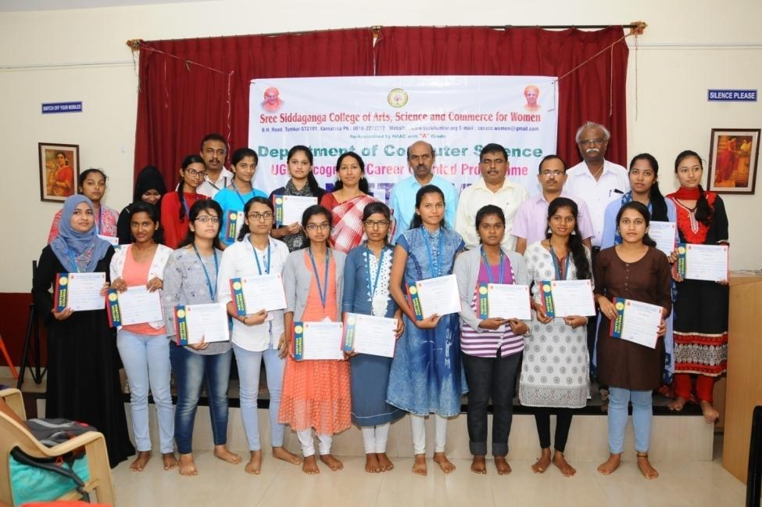
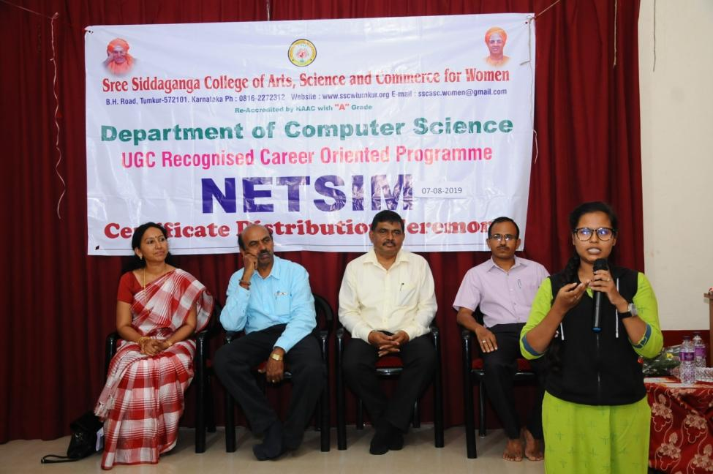
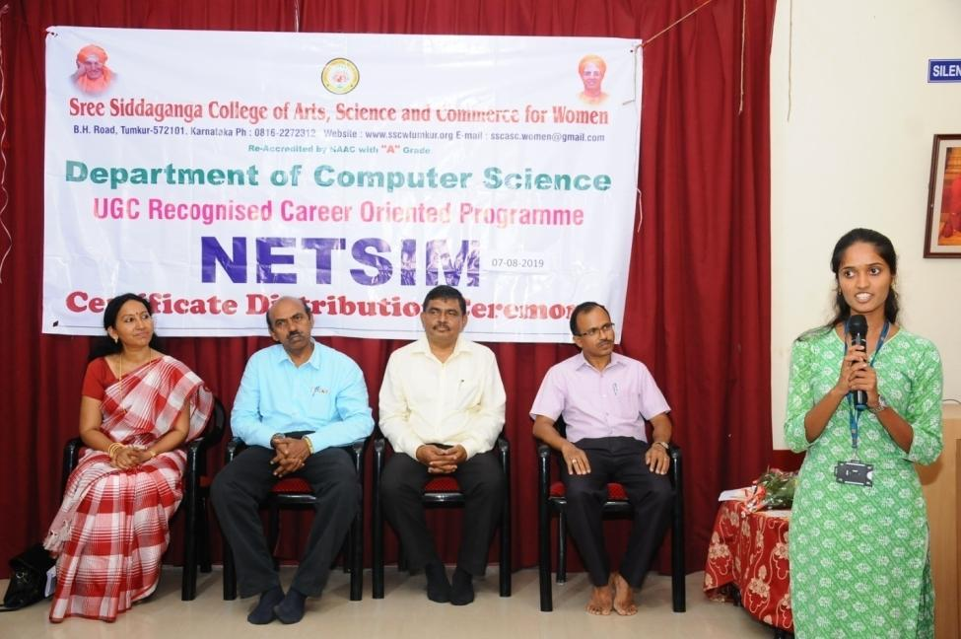
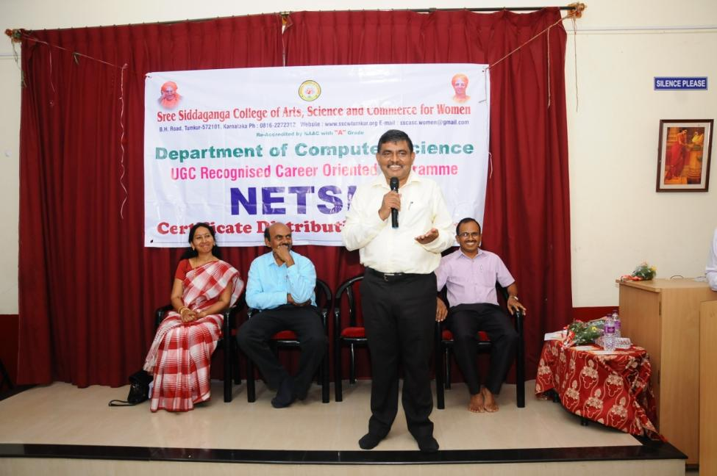
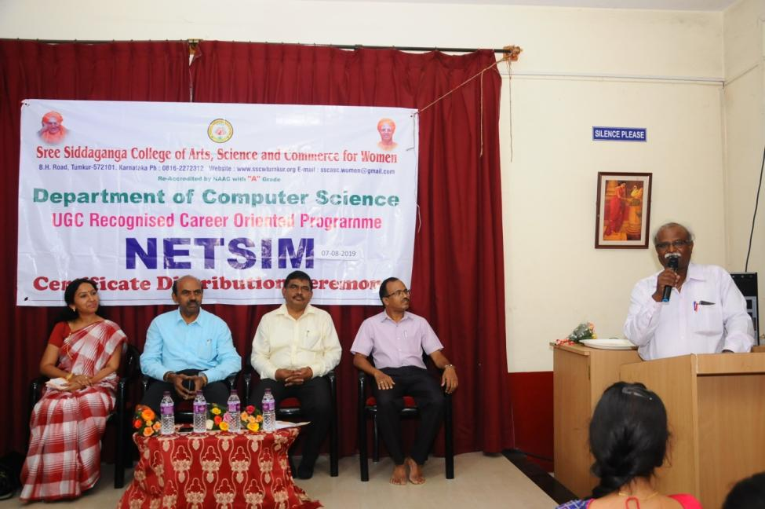
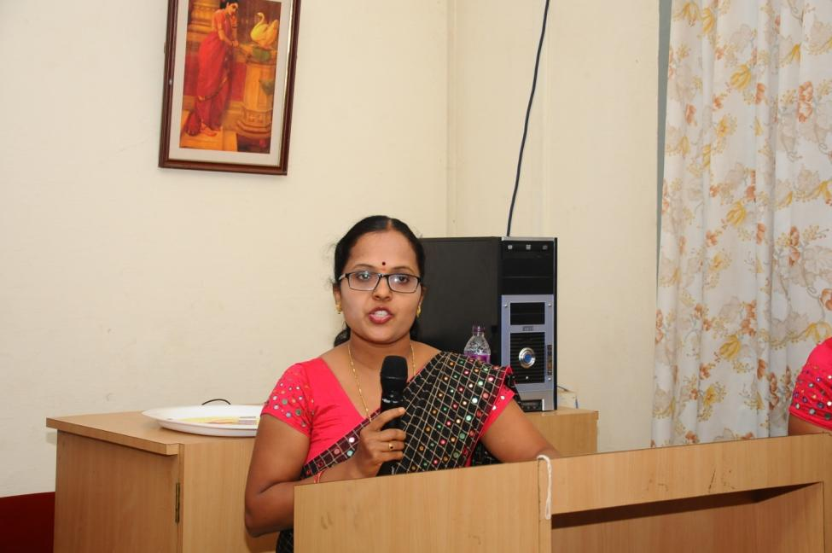
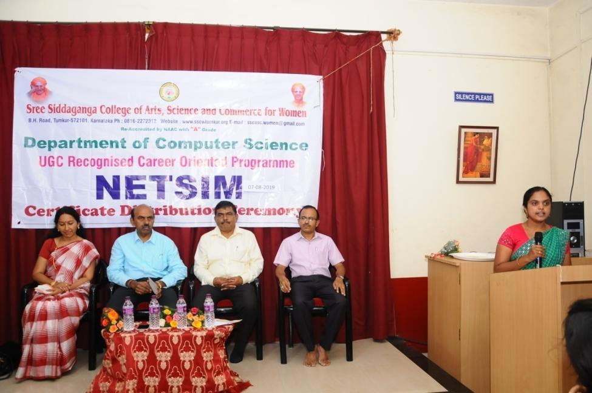

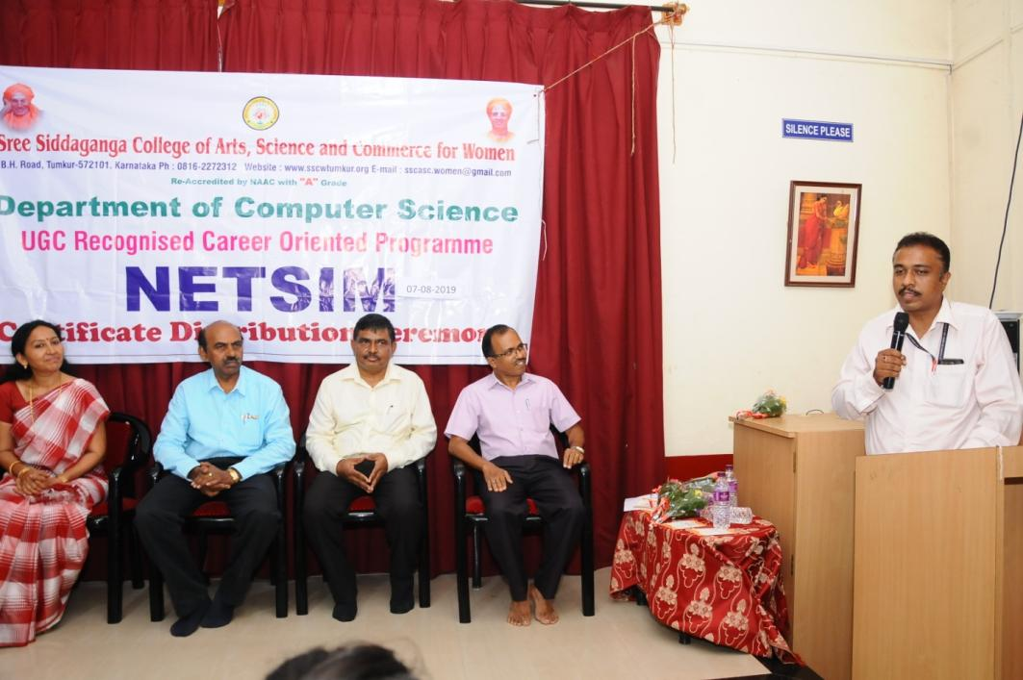
 | NETSIM COURSE
 | Academic Year 2018-19
Certificate Course
Sl No | Name | Sl No | Name
1 | AFREEN TAJ | 36 | NIKHITHA K
2 | AISHWARYA SETTY | 37 | POOJASHREE
3 | AMREEN ZEHRA | 38 | RAKSHITHA A
4 | ANU R | 39 | RAKSHITHA H M
5 | ANUSHA H K | 40 | RANJITHA T K
6 | BHAVANA A | 41 | REKHA L
7 | BHUMIKA JAIN P | 42 | S DIVYASREE
8 | CHANDANA A R | 43 | SAHANA M
9 | CHANDANA S | 44 | SAISREE H R
10 | CHANDANA K M | 45 | SANIYA FATHIMA
11 | CHANDRAKALA S | 46 | SHILPASHREE S R
12 | DEEPIKA D | 47 | SHUBHA P
13 | DEEPTHI B S | 48 | SINDHU G B
14 | GAGANA A U | 49 | SNEHA H S
15 | HAMSAVEENA | 50 | SUSHMA R
16 | KAVYA M | 51 | SUPRIYA N N
17 | KAVYA M | 52 | TAFSEER FATHIMA
18 | KAVYA T R | 53 | TANUSHREE C V
19 | KEERTHANA D M | 54 | TEJASHWINI
20 | KEERTHI SHETTY V N | 55 | THANUJAKSHI V S
21 | KOMALA | 56 | THEJASWINI M S
22 | KRUPA H R | 57 | VATHSALA YADAV D G
23 | LAKSHMI H | 58 | VIDYA K C
24 | LAVANYA V R | 59 | VIDYASHREE T R
25 | MAMATHA C M | 60 | VIDYASHREE Y H
26 | MANASA G N
27 | MEGHANA M S
28 | MEGHANA G S
29 | MONIKA H J
30 | MONISHA N S
31 | N PUSHPA
32 | N R TEJASWINI
33 | N SHAHANA
34 | NAMRATHA J
35 | NAYANA D K

NETSIM COURSE
Academic Year 2018-19
Diploma Course
Sl No | Name | Sl No | Name
1 | ANUSHA B H | 35 | SALMA SIDDIQA
2 | BHAVANA R N | 36 | SANOBER FATHIMA
3 | BHAVYA P | 37 | SHALINI K
4 | BHUVANA C T | 38 | SHAMSHIYA REHMANI
5 | CHAITRA | 39 | SHILPA H P
6 | CHAITRA B R | 40 | SHRAVANI V S
7 | CHANDANA D | 41 | SUMA A P
8 | CHANDANA K N | 42 | SUPRIYA H P
9 | CHANDANA N | 43 | SUSHMA G T
10 | DEEPASHREE H | 44 | SUSHMA M
11 | DEEPASHREE R | 45 | SUSHMA S A
12 | GAGANADEEPA N L | 46 | TANASHREE N J
13 | GAYATHRI K H | 47 | TASMIYA NIKHATH
14 | HAJEERA KHAN | 48 | TEJASHWINI M
15 | HAMSAMURTHY S | 49 | TEJASWINI M
16 | JASWINI T | 50 | TANUSHREE B Y
17 | KAVITHA S M | 51 | VANISHREE J
18 | KIRANA B | 52 | VARALAKSHMI M
19 | MEGHANA H G | 53 | VARSHINI
20 | MEGHANA S P | 54 | VARSHITHA K
21 | N PAVITHRA | 55 | VIDYASHREE G N
22 | NETHRAVATHI K S | 56 | VINUTHA D V
23 | PADMAVATHI D G | 57 | YAMUNA K V
24 | PAVITHRA S P | 58 | YAMUNA N V
25 | POOJA G
26 | POOJA T Y
27 | PUSHPALATHA K R
28 | R SUSHMA SWARAJ
29 | RAJESHWARI C
30 | RENUKA A
31 | ROOPASHREE
32 | RUCHITHA B M
33 | SADIYA KAUSER
34 | SAHANA YADAV K M

